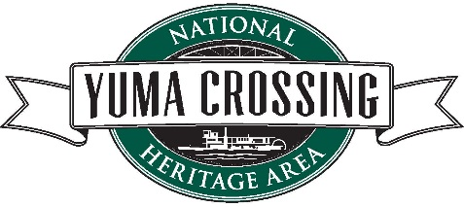

EXECUTIVE DIRECTOR’S NEWSLETTER BLOG – OCTOBER 2019

“REDISCOVERING THE SPIRIT OF GIVING & CIVILITY”

By Lowell Perry

September 18, 2019

The title song from Marvin Gaye’s critically acclaimed album “What’s Going On” shined the light on a number of social issues that may be even more relevant today than they were when the album was released in 1971. It seems we don’t dialogue anymore. Our conversations instead tend to be zero sum game monologues in which someone has to win, while the other has to lose, rather than meeting in the middle for a more civil discourse in which we find common ground. I don’t think I have ever seen this level of selfishness perpetuated on the national stage like unfortunately is occurring today.
We don’t have to follow that destructive formula in Yuma. Yumans have historically demonstrated an inclination to come together around common goals for the betterment of our community, such as when local companies and individuals contributed in excess of $70,000 in a 60 day period to prevent the state from closing the Yuma Territorial Prison, and the Colorado River State Historic Park, formally known as the Quartermaster Depot. It was a dynamic display of generosity and passion for preserving Yuma’s history. The Yuma Crossing National Heritage Area (YCNHA) is looking to reinvigorate that spirit of giving through participation in this year’s Giving Tuesday beginning December 3, 2019.
According to Wikipedia, Giving Tuesday, often stylized as #GivingTuesday for the purposes of hashtag activism, refers to the Tuesday after U.S. Thanksgiving in the United States. It is a movement to create an international day of charitable giving at the beginning of the Christmas and holiday season. It was started in 2012 by the 92nd Street Y and the United Nations Foundation as a response to commercialization and consumerism in the post-Thanksgiving season (Black Friday and Cyber Monday).
We will begin a month long (12/03/19 to 1/03/20) campaign to raise a minimum of $20,000 to help support current YCNHA restoration efforts, in addition to raising awareness of a future kickoff of an even bigger campaign to address significant long-term preservation needs at the aforementioned parks. The YCNHA team will be visiting with the local business community to ask for support in the form of a direct gift, and or a 100% match for all employee gifts.
The Yuma Crossing National Heritage Area is hopeful that Mayor Nicholls will declare December 3, 2019 an official Giving Tuesday for the City of Yuma. We are encouraging all citizens to give of their time, talent, and/or treasure. Yes, we would love for you to invest with us. However, Giving Tuesday is a day to remember and support your favorite charity or charities. We believe the Yuma Crossing National Heritage Area, which is also a National Historic Landmark, is well-positioned to make Yuma more of destination, rather than a drive-through gas stop between San Diego and Phoenix. With your support, this will become a “Mega-Park” that folks from all over the southwest will want to come and visit. Join the movement!

LP

