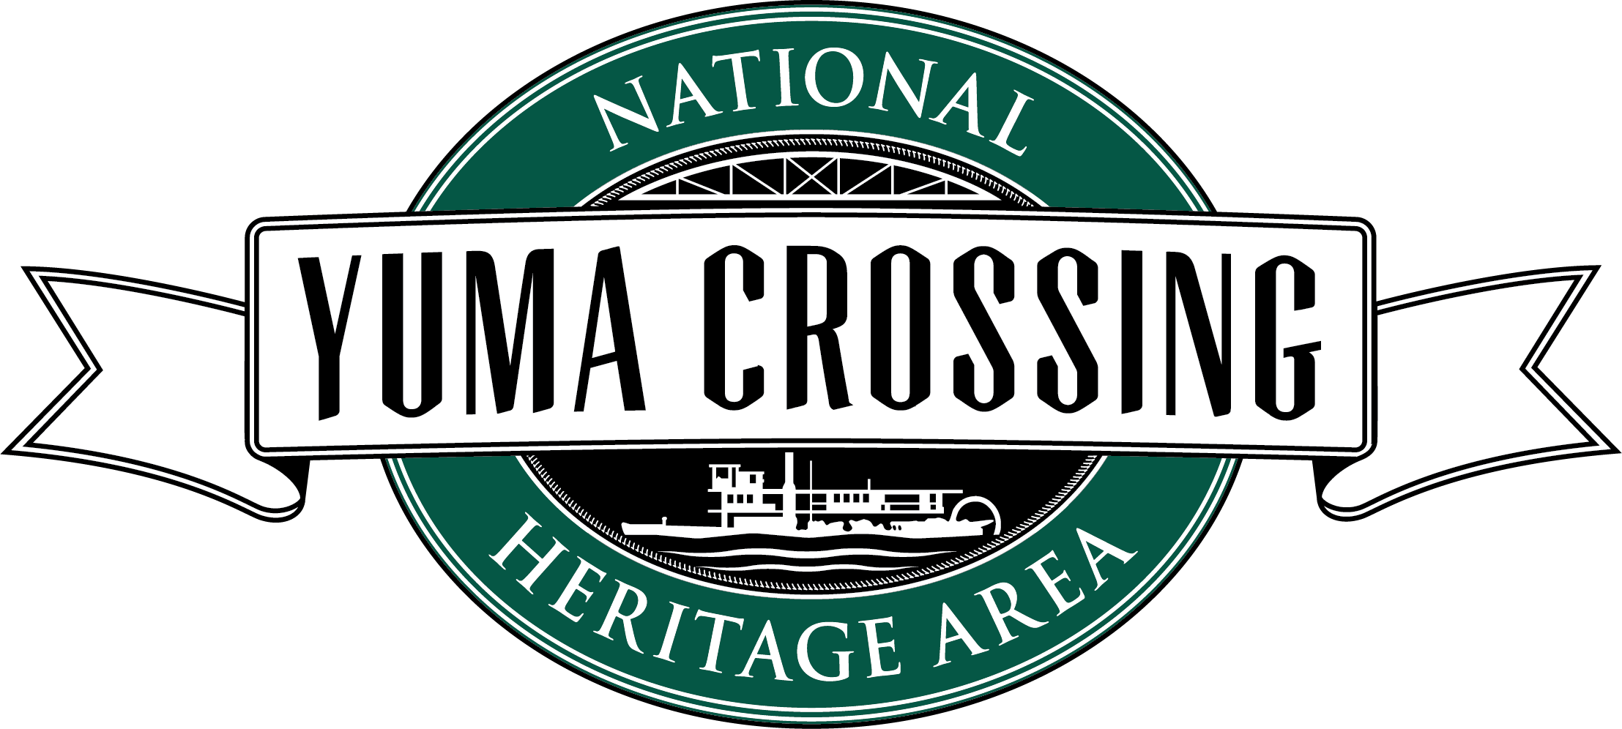
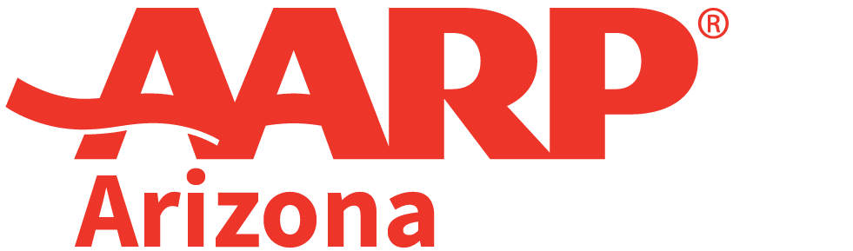

FOR IMMEDIATE RELEASE
June 29, 2022
MEDIA CONTACT:
Alex Juarez, ajuarez@aarp.org, 602-262-5169

Cathy Douglas, Cathy.Douglas@yumaaz.gov, 928-373-5199

AARP Arizona Selects Yuma Crossing National Heritage Area For a 2022 Community Challenge Grant
The grant will be used to install ADA compliant picnic tables, benches and bike racks

YUMA, Arizona— Today, AARP Arizona announced that Yuma Crossing National Heritage Area has been selected to receive a 2022 AARP Community Challenge grant, one of 6 grantees chosen statewide.

The grant will be used to install ADA compliant picnic tables, benches, and bike racks to create an inviting resting and gathering area at a new nature park frequented by older adults seeking to improve their health and wellness in a natural setting at Yuma East Wetlands.

“We are incredibly proud that AARP selected Yuma Crossing National Heritage Area for this investment in our community,” stated Cathy Douglas, grant manager for the Yuma Crossing. “AARP is a nationwide leader in making communities more livable for all residents. We are honored that AARP see’s the tangible value this project will bring to our area.”

This project is part of the largest group of grantees to date with $3.4 million awarded among 260 organizations nationwide. Grantees will implement quick-action projects that help communities become more livable in the long-term by improving public places; transportation; housing; diversity, equity and inclusion; digital access; and civic engagement, with an emphasis on the needs of adults age 50 and over.

With this grantee class, AARP is bolstering its investment of affordable and adaptable housing solutions in response to the national housing crisis. With additional funding support from Toyota Motor North America, the program is also increasing its support of projects that improve mobility innovation and transportation options.

All projects are expected to be completed by November 30, 2022, and are designed to achieve one or more of the following outcomes:

- Create vibrant public places by improving open spaces and parks and activating main streets.
- Deliver a range of transportation and mobility options by increasing connectivity, walkability, bikeability, wayfinding, and access a wider range of transportation choices.
- Encourage the availability of a range of housing by increasing accessible and affordable housing solutions.
- Ensure a focus on diversity and inclusion while improving the built and social environment of a community.
- Support communities’ efforts to build engagement and leverage funding available under new federal programs through laws including the American Rescue Plan Act, the Infrastructure Investment and Jobs Act, and more
- Increase Civic Engagement with innovative and tangible projects that bring residents and local leaders together to address challenges and facilitate a greater sense of inclusion.
- Other community improvements, including Health Services, Community Development, and Coronavirus Pandemic Recovery.

“We are incredibly excited to support Yuma Crossing National Heritage Area as they work to make immediate improvements, encourage promising ideas and jumpstart long-term change in Yuma,” shared Dana Marie Kennedy, AARP AZ State Director. “Our goal at AARP Arizona is to support the efforts of our communities to be great places for people of all backgrounds, ages and abilities.”

Other Arizona grantees include Camp Verde Parks and Recreation, Change Labs in Tuba City, Elaine in Phoenix, G.A.S.K.I.N Charity in Phoenix and Red Feather in Flagstaff. The full list of grantees can be found at www.aarp.org/communitychallenge.

The Community Challenge grant program is part of AARP’s nationwide Livable Communities initiative, which supports the efforts of cities, towns, neighborhoods and rural areas to become great places to live for people of all ages. Since 2017, AARP Arizona has awarded fifteen grants and $181,657 through the program to nonprofit organizations and government entities across the state. View the full list of grantees and their project descriptions at www.aarp.org/communitychallenge and learn more about AARP’s livable communities work at www.aarp.org/livable.

# # #

About AARP
AARP is the nation’s largest nonprofit, nonpartisan organization dedicated to empowering people 50 and older to choose how they live as they age. With a nationwide presence and nearly 38 million members, AARP strengthens communities and advocates for what matters most to families: health security, financial stability and personal fulfillment. AARP also produces the nation's largest circulation publications: AARP The Magazine and AARP Bulletin. To learn more, visit www.aarp.org, www.aarp.org/espanol or follow @AARP, @AARPenEspanol and @AARPadvocates, @AliadosAdelante on social media.​

The Yuma Crossing National Heritage Area (YCNHA) is a non-profit 501 (c) (3) organization in Yuma, Arizona that has been restoring, preserving, maintaining, and promoting Yuma’s history and culture since 2002. Over the past two decades, the YCNHA has been the driving force behind Yuma’s downtown and riverfront transformation. Sitting at the narrows of the Lower Colorado River, Yuma was known as “The Gateway to the Great Southwest” and is the oldest city established on the Colorado River. The Yuma Crossing National Historic Landmark, the Yuma Territorial Prison and Colorado River State Historic Parks, and over 3 miles of contiguous riverfront parks, trails, and 400 acres of restored wetlands reside within the boundaries of the YCNHA. To learn more, visit www.yumaheritage.com.

