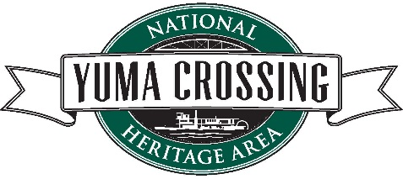

INCREASE THE FLOW OF WATER TO THE YUMA WETLANDS: REGIONAL GEM BEING IMPACTED BY DROUGHT

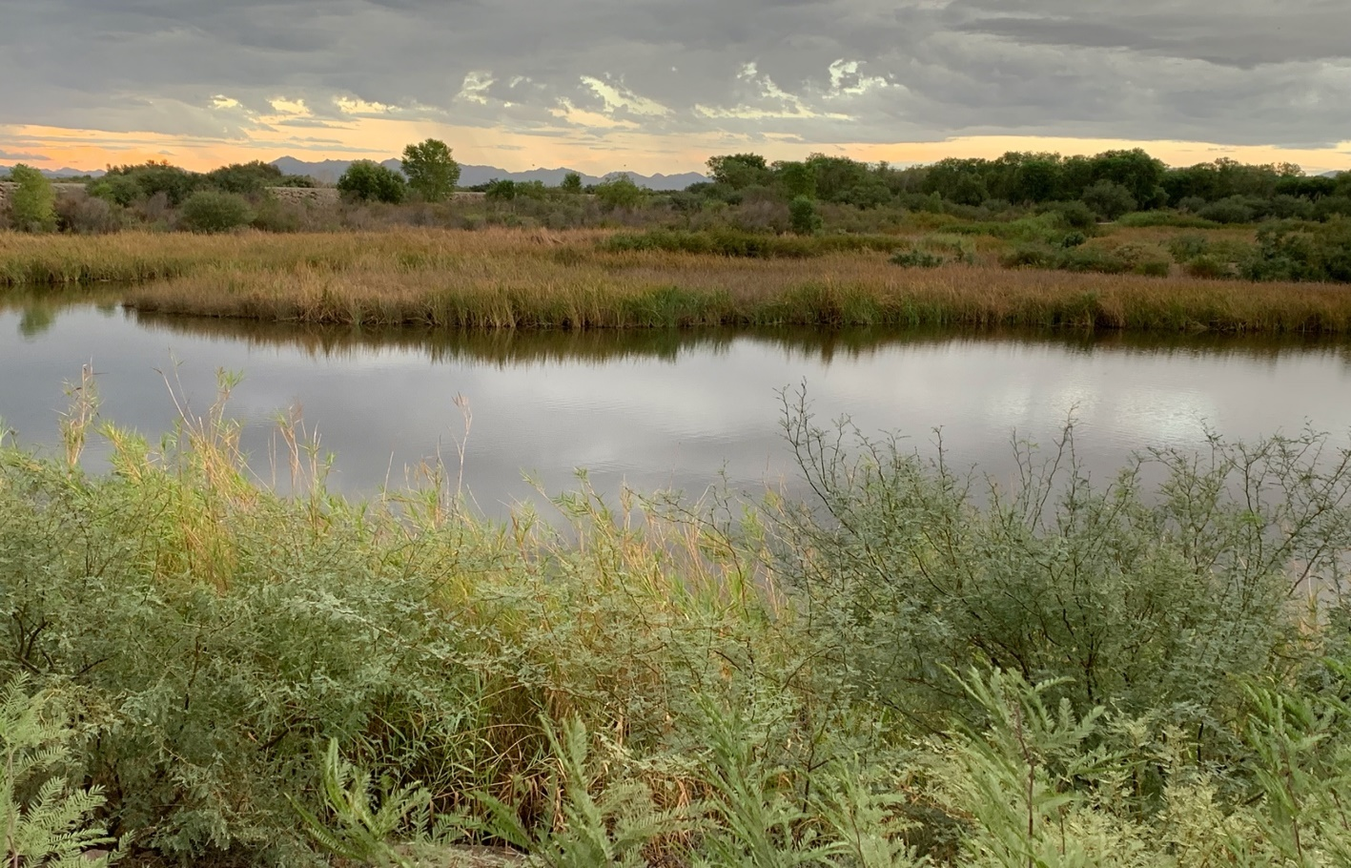
By
Lowell Perry, Jr., Executive Director, Yuma Crossing National Heritage Area & Fred Phillips, Fred Phillips Consulting
The effects of sustained drought are real. One need only look to the proliferation of wildfires, dying vegetation, and record temperatures across the country to realize that scientific fact. It is of special concern to those of us living in the desert southwest, where water is a premium commodity, especially in Yuma, Arizona. The Yuma area, including the nearby Imperial Valley in California, both along the lower Colorado River, produces nearly 90% of the leafy fresh vegetables grown in the United States from November through March.
Yuma is also home to another desert phenomenon called the Yuma East Wetlands. The Yuma Crossing National Heritage Area (YCNHA) led the development of this multi-million dollar project. Residents, businesses, and visitors alike to Yuma, continue to enjoy hiking, biking, birding, fishing, and tubing there, among other recreational activities.
YCNHA is one of 55 current congressionally authorized national heritage areas across the country. In partnership with the Quechan Indian Tribe, the City of Yuma, the U.S. Bureau of Reclamation and other strategic partners, the YCNHA has transformed the downtown riverfront from a literal dump and dangerous hobo camp into an extensive riverfront multi-use trail system, several beautiful riverfront parks, and over 400 acres of restored wetlands and riparian habitat. Through systematic elimination of non-native vegetation such as salt cedar and phragmities, both of which consume large quantities of water, and replacing the non-native with native Mesquite, Cottonwood and other native ground cover, we are helping to conserve water. We also believe that our efforts support our thriving agricultural economy. Our efforts have also resulted in the comeback of previously endangered and threatened species such as the Yellow-billed Cuckoo and Ridgeway’s Rail (Yuma Clapper Rail).

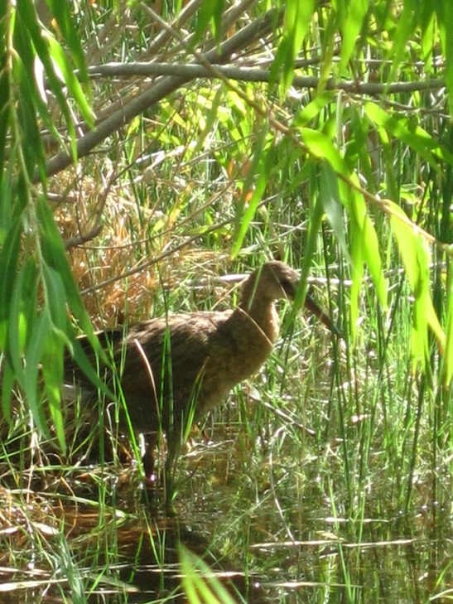

The Endangered Yuma Clapper Rail in its YEW Home
However, the reduced flow of water from the Colorado River caused largely by ongoing drought in the region could cause an existential crisis for the Wetlands, putting at risk a 20 year, over $10 million investment. Several factors contribute to this situation.
1) The river typically flows higher in non-drought years, to a point to where farmers, who account for about 74% of total water usage in the area, will periodically cancel their water orders after rainfall events. The cancelled water orders will already be on their way to Yuma known as Non Storable Flows (NSF). The NSF provide high enough river levels to flood the wetlands. This used to happen multiple times a year, which provided plenty of low salinity “sweet” water to the Yuma East Wetlands (YEW). Now, most of these NSF divert into the Drop II reservoir. We have had a great reduction in these NSF flows in the last three years due to drought. When these NSF happen today, they end up in the Drop II reservoir and rarely make it to the YEW, which means the YEW is not getting the adequate amount of water needed to sustain the flora and fauna in the wetlands and riparian forests restored by the Yuma and Quechan communities.
2) The decant line from the City of Yuma water treatment center has also been a critical water input into the YEW. In a typical year, this source fed the YEW with up to 365-acre feet of “sweet” water a year. This meant lower salinity, good clean water for over a decade in the YEW. However, over the last two years the water intended from this source has stopped flowing into the YEW. The City of Yuma is actively working on fixing this issue in a satisfactory manner. The process is both time consuming and expensive. Meanwhile, the lack of this critical water has resulted in the death of some high quality cottonwood and willow forest. Some cottonwood trees exceeding 80’ tall, which provided some of the best birding/recreational habitat in the Yuma East Wetlands, are now dead.
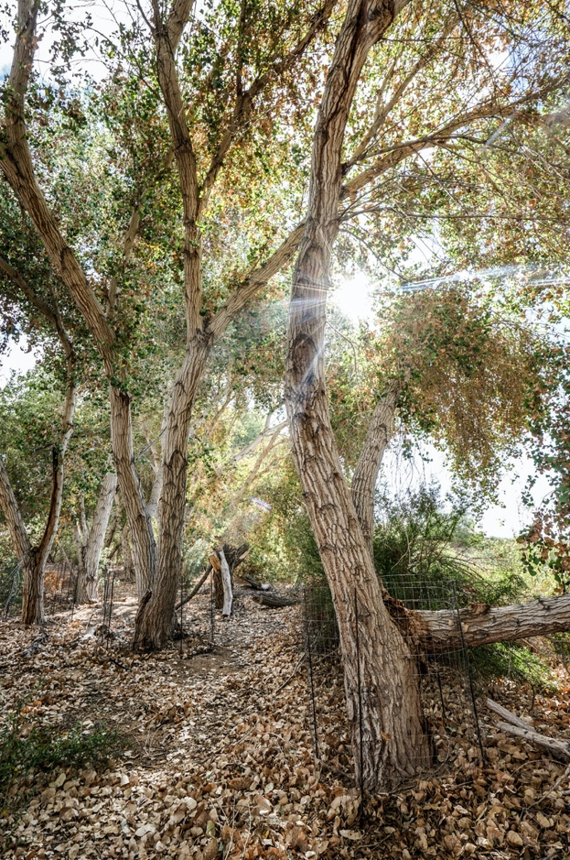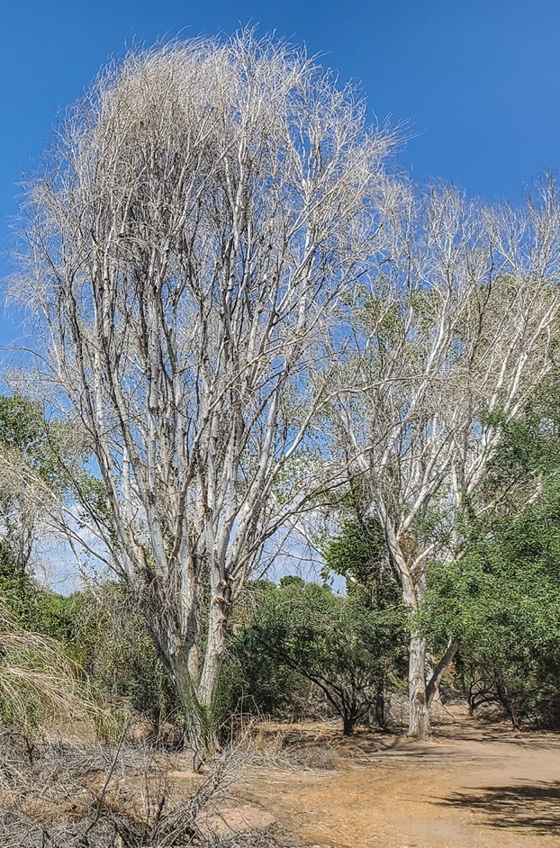
*80 Foot tall cottonwoods in (2019 )were planted as 1’ saplings 10 years ago in the YEW, because of water flow challenges and the continuing drought crisis they are now dead (right picture)
3) Another important source of water for the Yuma East Wetlands has been the DEPOC-4 well. This U.S. Bureau of Reclamation (USBR) well pumps groundwater from the Yuma Valley to support agricultural production and to meet international treaty requirements with Mexico for Colorado River salinity levels. This well originally provided flow into the YEW 6-9 months a year with up to 3-acre feet of water a day, but it continues to run less frequently or not at all when salinity levels run too high.
These water sources are critical to maintaining the marsh and riparian habitats of the aforementioned endangered wildlife that currently calls the YEW home. Without the requisite supply of water, these beautiful creatures will likely disappear from the YEW again, not to mention putting the long-term survival of this decade’s old, multi-million dollar community investment at risk.
Meeting the Challenge
It will take active collaboration among the YEW partners and stakeholders to accomplish the goal of ensuring adequate fresh water sources for the site. U.S. Bureau of Reclamation has been a valuable partner and supporter to the mission of the YCNHA and YEW since its inception. One option to consider may be conducting pulse flows of water down the river through Yuma to replace this NSF the community counted on for decades. Bringing in other potential project partners like the numerous Yuma irrigation districts to be active participants would also help in brainstorming solutions. Another option is to extend the pump and canal system already developed in the YEW.
What is at stake if we fail to act in an intentional manner? Multiple threatened and endangered species that have reappeared in the Yuma East Wetlands because of restoration efforts may disappear from this project again. The Lower Colorado River Multi-Species Conservation Program has provided critical maintenance funding for the YEW to support those species. Lack of sufficient water not only has a negative impact on the wildlife, and native vegetation, but also jeopardizes the availability of inexpensive family recreational activity along the river. The latter is especially important as we try to come out of sequestration stemming from the pandemic, and outdoor activities should be at a premium.

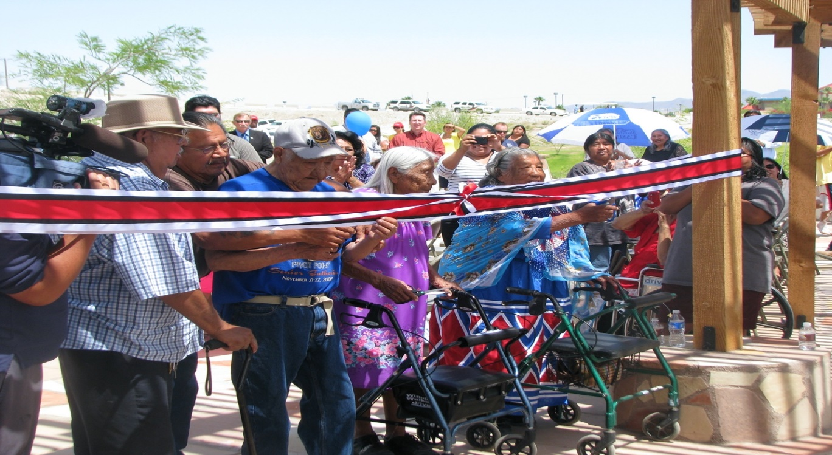
Quechan Tribal Elders Dedicating Sunrise Park in the Yuma East Wetlands
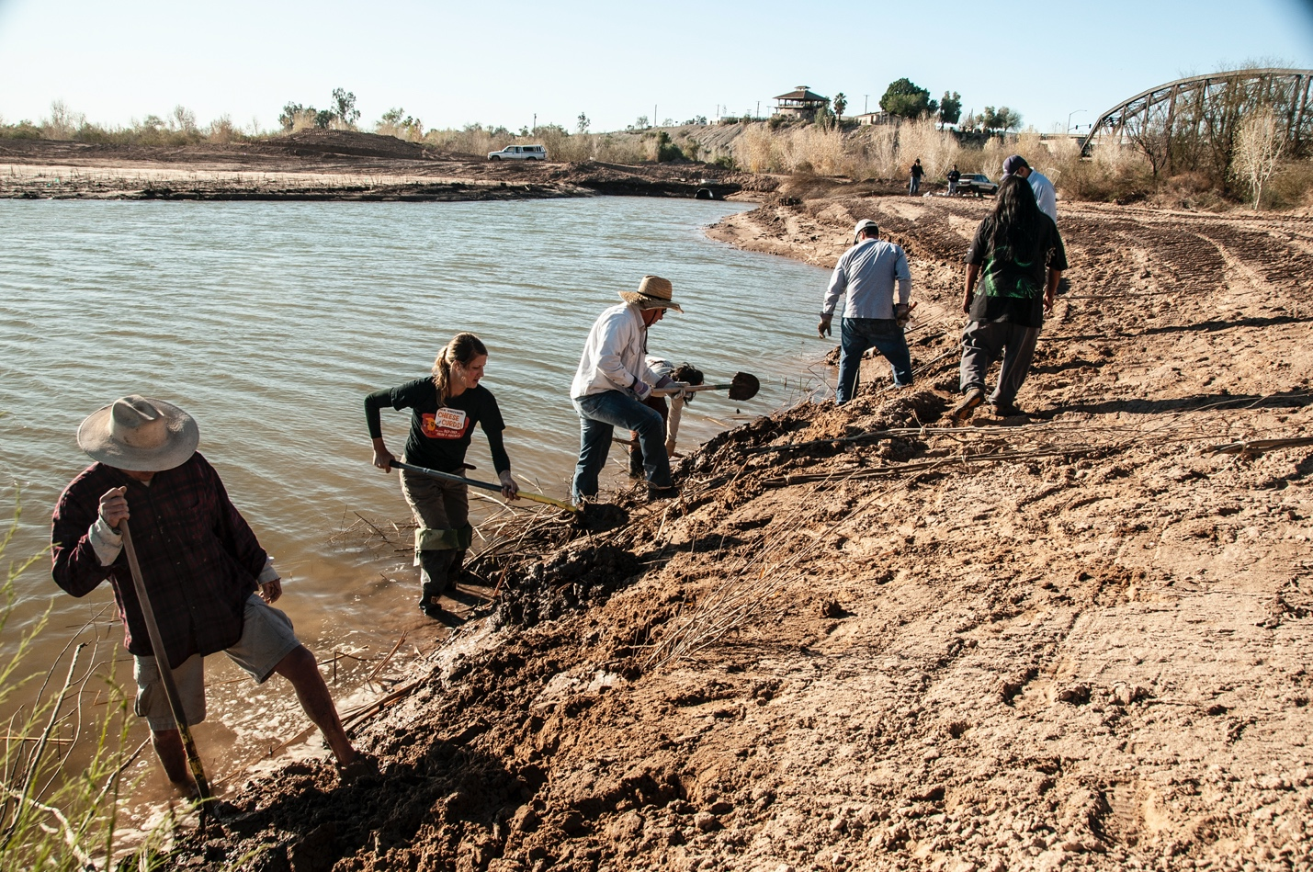
Yuma and Quechan Community Volunteers planting native willows in the YEW
- So what can I do, you ask? A few things include, but are not limited to: Contribute to the Yuma Crossing National Heritage Area to help raise $50,000 to build needed canal/pump infrastructure to provide critical water flow in the YEW
- Voice your support to local, state and federal agencies to help assist the Yuma East Wetlands with its ongoing challenges
- Volunteer your time helping the YEW staff with the management and construction of the YEW
- Visit Yuma and the wetlands parks and see this incredible transformation
###
About the authors:
Lowell Perry, Jr is known as an innovative senior executive with a proven track record of success in the nonprofit and for-profit sectors, as well as a broad based background in the areas of general management, fundraising, strategic alliances, marketing, external affairs, education, planning, team building, community outreach, diversity, equity & inclusion, collective impact, and board engagement.
Prior to his arrival to Yuma, he led the Central Promise Neighborhood, a program of the Sisters of Charity Foundation of Cleveland. Other business highlights include serving as Big Brothers Big Sisters of America (BBBSA) Chief Diversity Officer, SVP Corporate & Community Engagement. Prior to that, Perry was CEO of Big Brothers Big Sisters (BBBS) of Middle Tennessee and led that regional agency to set records of 2812 children served and unrestricted revenue of nearly $3million. He was a BBBSA CEO of the Year winner, served on the BBBSA Nationwide Leadership Council and chaired the national African-American Advisory Council.
A Yale graduate and polished keynote speaker, Perry has done numerous sales and marketing training films, voiceovers, and commercials. He has also appeared in feature films and television, including Déjà vu, starring Denzel Washington, Nothing but the Truth, featuring Kate Beckinsale, Drop Dead Diva, and Nashville.
He and his lovely wife Kathleen have three children Trey, Tucker Nichol, and Trenton, and granddaughters Olivia, Zoe, and Reese, with grandson Lyric on the way. Life member of Alpha Phi Alpha Fraternity, Inc., and voted one of Nashville’s 25 Most Beautiful People in 2011.
Fred Phillips is an award winning landscape architect whose internationally recognized practice focuses on landscape ecological restoration. He is the President and owner of Fred Phillips Consulting, LLC (FPC). He has more than 25 years of experience undertaking ecosystem restoration, land planning, grant writing, and landscape design in the United States, Mexico and Indonesia. Fred received his Bachelor of Science degree in Landscape Architecture in 1993 from Purdue University.
Fred Phillips established FPC in 1999, Since then, he has designed and constructed more than 4,000 acres of restored wetland and riparian habitat, combining technical design skills with grant-writing and the rare “people skills” of consensus-building among diverse stakeholders. He has pioneered innovative techniques to remove invasive salt cedar and phragmites and restore these areas with native riparian revegetation in the Southwest United States.
Other large-scale habitat restoration projects Fred has either planned and/or implemented include projects throughout the Southwest United States, Mexico and Indonesia. Fred’s work has been featured in magazines such as the New Yorker, Landscape Architecture, Restoration Ecology, Arizona Highways, and a multitude of periodicals and books. Recently he received the Distinguished Alumni Award from the School of Landscape Architecture at Purdue University.
About Yuma Crossing National Heritage Area:
Designated by Congress, a National Heritage Area has unique, nationally significant qualities and resources. It is a place where a combination of natural, cultural, historic and recreational resources have shaped a cohesive, distinctive American landscape. We employ a partnership approach to heritage development involving collaborative planning around a theme, industry and/or geographical feature that influenced the nation’s culture and history. This planning strategy encourages residents, government agencies, nonprofit groups and private partners to agree on and prioritize programs and projects that recognize, preserve and celebrate many of America’s defining landscapes. We also seek short and long-term solutions to conservation and development challenges by fostering relationships among regional stakeholders and encouraging them to work collaboratively to achieve shared goals.
In Yuma, the story of water and its impact on the people and land is the key to understanding our history. Sitting at the narrows of the Lower Colorado River, Yuma is the oldest city established on the Colorado River. The Yuma Crossing National Heritage Area encompasses seven square miles along the Lower Colorado River in Yuma, Arizona. It includes the Yuma Crossing National Historic Landmark, the Yuma Territorial Prison and Colorado River State Historic Parks, , and more than 3 miles of contiguous riverfront parks, trails, and 400 acres of restored wetlands.
#ycnha #yew #coloradoriver #riverdrought #climatechange #cottonwoods #mesquite #savethewetlands #alphaphialpha #outdoorafro #ANHA #NPS #conservation #Audubon @Yuma East Wetlands @Yuma Crossing National Heritage Area

